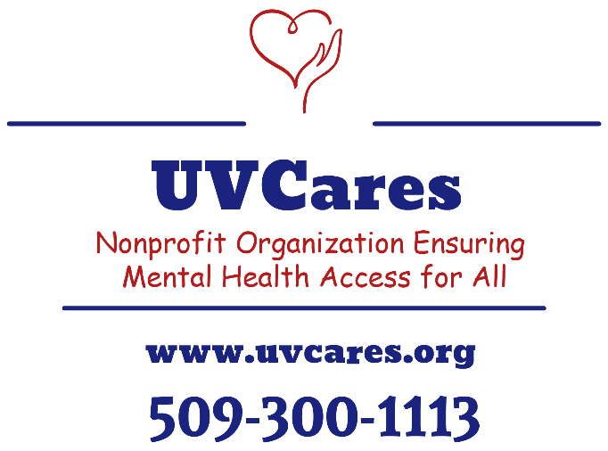

Practicum Internship Programs

UVCares Behavioral Health Clinic
Adults – Children – Adolescents
~
Mental Health Assessments & Counseling
Substance Use Disorder Assessments & Treatments

Status: Established, modality is tele-mental health and Substance Use Disorder programs throughout Washington State
Executive Director: Rebekah Subido, EMBA
Supervisors: As assigned by UVCares Behavioral Health Executive Director
Website: http://www.uvcares.org
Program capacity: 4 PhD students & 4 Master students

Summary:
Mental Health, Substance Use Disorder, and Counseling Practicum including multiple tele-behavioral health programs.

PROGRAMS

Adult and adolescent behavior health for individuals, couples, and family units.
Therapy provided throughout Washington State with primary focus on rural communities with limited access to mental health.

Benefits
- Practical experience with ages 6+ throughout the life continuum.
- Rural community focus, yet also includes clients from large metropolitan communities.
- No commute, yet intern must provide a private and quiet room that provides an appropriately visually therapeutic environment that supports HIPAA compliance.
- Student must have access to a computer with audio and video capabilities.
- Fairly flexible day and evening hours.

School Therapy Program
Therapy provided throughout Washington State School Districts with primary focus on rural communities with limited access to mental health.

Benefits
- Multidisciplinary setting interfacing with students, teachers, families, and staff of school districts.
- Rural community focus, yet also includes clients from large metropolitan communities.
- Multi-faceted psychological testing with students to enhance the academic needs and posturing for student success.
- No commute, yet intern must provide a private and quiet room that provides an appropriately visually therapeutic environment that supports HIPAA compliance.
- Student must have access to a computer with audio and video capabilities.
- Hours traditionally occur between 9:00 am and 5:00 pm.

Drug and Alcohol Program
Substance Use Disorders with assessments and treatment provided throughout Washington State with primary focus on rural communities with limited access to mental health.
Individual assessment and treatment that includes group therapy focused on substance use disorder with biological testing performed via collaboration with external provider with results incorporated into mental health therapy services.
Intern will focus on the mental health component of SUD.

Benefits
- Multidisciplinary setting interfacing with adolescents, adults, and family units.
- Rural community focus, yet also includes clients from large metropolitan communities.
- No commute, yet intern must provide a private and quiet room that provides an appropriately visually therapeutic environment that supports HIPAA compliance.
- Student must have access to a computer with audio and video capabilities.
- Fairly flexible day and evening hours.

Group Therapy Focusing on Depression and Anxiety Disorders
Therapy provided throughout Washington State with primary focus on rural communities with limited access to mental health.
Group therapy focused on depression and anxiety disorders among adolescents and adults. Adolescent and adults will be in separate groups.

Benefits
- Multidisciplinary setting that includes adolescents and adults
- Rural community focus, yet also includes clients from large metropolitan communities.
- No commute, yet intern must provide a private and quiet room that provides an appropriately visually therapeutic environment that supports HIPAA compliance.
- Student must have access to a computer with audio and video capabilities.
- Most hours are performed in the evening and likely include Saturday evenings.

